The Effectiveness of HubERT Model for Discrete Representation of Speech for Speech Processing Applications

Gabriel O. Sobola^{1*}, Emmanuel Adetiba^{1,2}, Olabode Idowu-Bismark¹, Oluseyi O. Ajayi³, Raymond Jules Kala⁴, Abdultaofeek Abayomi ⁵, Oshin Damilola¹, Toyin Olaitan⁶
¹Department of Electrical and Information Engineering, Covenant University, Ota 112104, Nigeria
² HRA, Institute for Systems Science, Durban University of Technology, Durban 4001, South Africa
³Department of Mechanical Engineering, Covenant University, Ota 112104, Nigeria
⁴International University of Grand-Bassam, Grand-Bassam, Côte d'Ivoire
⁵IASRG, Summit University, PMB 4412, Offa 250101, Kwara State, Nigeria
⁶Faculty of Engineering, Built Environment and Information Technology, Walter Sisulu University, Buffalo City Campus, East London 5200, South Africa

Corresponding Author Email*: gabriel.sobola@covenantuniversity.edu.ng

Abstract
In the past, speech synthesis and speech recognition models were trained using Mel-spectrograms of the speech as inputs and this has achieved quite outstanding results. However, it comes with its own drawbacks such as an increase in the computational complexities of the artificial intelligence (AI) models developed, and the introduction of errors during training. Beside all these, is the sourcing of large volumes of labeled speech data and a possible solution includes developing an unsupervised plus self-supervised training approach using unlabeled data that do not require the transcripts, hence the hidden discrete units’ representations. Recently, trends in speech synthesis and recognition domain have shifted towards the utilization of discrete representation of speech which are consequently fed as inputs to such models. Thus, studies have used the discrete representation of speech with discrete values including integer for elements of vector’s representation. This has resulted in the state-of-the-art Bilingual Evaluation Understudy (BLEU) scores. Hidden Unit Bidirectional Encoder Representation of a Transformer (HuBERT), which is a self-supervised model leverages on the Bidirectional Encoder Representation of a Transformer (BERT) model (masked language modeling) for the generation of hidden discrete units for audio inputs unlike texts for BERT. In this paper, HuBERT discrete units with unit HiFi-GAN results were first compared with spectrogram based HiFi-GAN. Thereafter, unit HiFi-GAN based HuBERT was compared with WavLM, and wav2vec unit HiFi-GAN discrete units-based model. The results of the experiments show HuBERT edges out on all experiments where it achieved a PESQ score of 1.40 in comparison to Wav2vec value of 1.33 at 45K steps. The results further show that WavLM is the better choice when an alternative approach to discrete units generation is needed utilising unit HiFi-GAN.
Keywords: Clustering, Discrete representation, HiFi-GAN, HuBERT model, Speech-to-speech translation, Wav2vec, WavLM

1. Introduction
Speech discretisation is a state-of-the-art approach that utilises a discrete representation of the Mel-spectrogram speech features or the raw speech waveform for the training of deep learning architecture. This involves clustering speech features into clusters using discrete numbers to reduce the dimension of the speech features needed for training the model developed. Each cluster point represents the discrete representation of the speech feature. The hidden unit can be likened to tokens or words in word strings or sentences, and by transforming speech mel-spectrograms to such forms enables natural language processing (NLP) models like transformers to be utilised on speech signals. Hidden units also reduce the complexity of such models due to low storage requirements [1-3] . Several models have been utilised to achieve this purpose. Among them are the Hidden Unit Bidirectional Encoder Representation of a Transformer (HuBERT) model [4], Wav2Vec 2.0 model - the first semi-supervised model applied on speech [5], Universal Speech Model (USM)-V1, USM-V2 models, [5-7] , Vector Quantisation Variational Auto Encoder (VQ-VAE) [8-9] , and WavLM-Large [10]. These models are based on clustering approach to group or partition speech frames into clusters. HuBERT leverages on the BERT model developed for texts which is applicable for NLP tasks such as sentiment analysis, text classification, and question answering [11]. While BERT is applied directly on texts, to extend its application (Masked Language Modelling) to speeches or sounds, hidden units must be generated via a separate clustering approach, hence the name Hidden Unit BERT (Hu-BERT). HuBERT is similar to Wav2Vec in terms of self-supervised pre-training but differs in terms of architecture and clustering approaches [5], [7]. In Wav2Vec 2.0, the clustering approach was part of the training process, while HuBERT develops separate clustering steps for its training.
Several studies have now begun to utilize the discrete representation of speech to train the AI models developed [12], [13]. The training of discrete speech is done in an unsupervised mode where only the speech is fed as input to learn the target hidden discrete representation. The discrete representation obtained is then utilized as training parameters for model development. In [8, 14] speech-to-speech translation (S2ST) models using the discrete speech representation were developed. For S2ST tasks, some other notable models developed are Speech-to-Unit Translation (S2UT) [15-21], where the source input and target output are the speech mel-spectrograms and discrete units respectively. In addition, in Unit-to-Unit Translation (U2UT) [19], the source input and target output languages representations for training are both in discrete units. The Unit-to-Speech Translation (U2ST) [15, 19, 20] however takes the source and target languages representations for trainings, the discrete unit representation and speech mel-spectrograms respectively. Hence, these approaches have been utilized to obtain enhanced results as compared to mel-spectrogram based models and have also incorporated auxiliary trainings [16, 17, 20-22], to enhance the training performances. When the target output predicted should be discrete units, these units are resynthesized into speech waveforms [18], [23] using some well-known vocoders such as HiFi-GAN [16-18], Graffin Lim, WaveRNN, WaveNet, Tacotron models etc. Discrete unit representations have also been explored for Text-to-Speech [24] and Speech-to-Text tasks [1], [2]. The majority of these discrete units in research works are obtained using HuBERT model [7], [15], [19], [20], [21] due to its model architecture and clustering approach. The model generates hidden units from both the speech Mel-spectrogram of raw speech and transformer encoder output and compares the two hidden units where some parts of the encoder hidden units’ output are masked and utilized to make predictions. Another advantage of the model is the utilization of the 6th and 9th transformer encoder layers for training during iterations 2 and 3 respectively to ensure that all features are well captured for training.
This review paper thus gives insights into the architecture of HuBERT, the models developed with it, its training and clustering approaches that demonstrated its uniqueness among other approaches for discretisation of speech mel-spectrogram features.

2. The HuBERT Model
This is a self-supervised learning model that was trained with speech audio data without the transcripts, while utilising certain amounts of labelled data for fine-tuning or evaluation of the model. The self-supervised learning suffers from some major problems including: the presence of multiple sound units in each speech utterance, unavailability of lexical or transcripts prior to training, and variation in the length of the sound units. The model learns the language and acoustic model typical of speech modelling over the continuous input data [7]. Hence, the performance of the HuBERT model relies on the clustering approach utilised during the pretraining of the model. Three models, including the HuBERT Base, Large, and X-large trained with 95 million, 317 million, and about 1 billion parameters respectively have been developed. The HuBERT Base uses 2 iterations while the Large and X-large use the third iteration with the first two iterations. For the first iteration, Mel- spectrogram speech features are clustered while in the 2nd iteration, the output of the 6th layer of the BERT Transformer encoder of the previous first iteration was clustered which enhances the performance of the model; in the third iteration the 9th layer BERT Transformer encoder output of the previous second iteration was utilised for clustering. The model was pretrained using Librispeech (960 hours) and Libri-Light (60K hours). HuBERT X-large achieved a 13% and 19% relative WER improvement over HuBERT Large when pre-trained on Libri-Light test-other, and dev-other evaluation subsets, respectively.

2.1 Variants of HuBERT Model
HuBERT Base is the first variant of HuBERT that was trained for two (2) iterations with 90 million parameters. HuBERT Large was trained for 1 iteration (last) plus the first 2 iterations with about 300 million parameters. HuBERT X-Large has about 1 billion training parameters and the training was for 1 iteration (last) plus the first 2 iterations.

3. Architecture of HuBERT Model
The state-of-the-art HuBERT model consists of a convolutional encoder, BERT transformer encoder, projection layer, clustering layer, and code embedding layer. This architecture as shown in Figure 1 consists of hidden units’ generation from both the output of the transformer encoder, and that of K-means clustering.
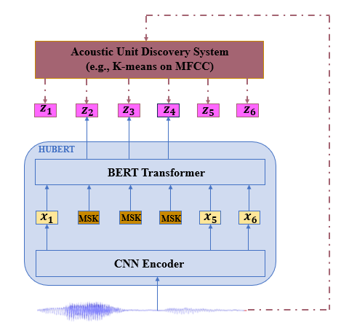
Figure 1: The HuBERT Model Architecture

3.1 Comparison of HuBERT Model to Wav2Vec 2.0 Model
The Architecture of HuBERT shares a relationship with the Wav2Vec 2.0 model, which is also a self-supervised model. Both are used to generate discrete representation of speech signals used for self-supervised or unsupervised training, with three models: HuBERT Base, Large & XLarge and Wav2Vec Base, Large, & XLarge. Both use a transformer BERT encoder with convolutional layer. The major differences between HuBERT and Wav2Vec 2.0 lie in the clustering approach, and the loss function computed. HuBERT utilizes separate clustering from training (off-line clustering) with K-means clustering while Wav2Vec 2.0 uses the output of the CNN network obtained during pre-training for clustering using Gumbel SoftMax approach. HuBERT uses the mel-spectrogram of the raw audio for the first iteration. It also uses the intermediate 6th and 9th layers of BERT transformer outputs of the previous iterations 1 and 2 for iterations 2 and 3 clustering respectively. HuBERT uses a predictive cross entropy loss function while Wav2Vec 2.0 utilises a contrastive loss function. Table 1 compares HuBERT and Wav2Vec 2.0 models while Table 2 highlights the strengths and weaknesses of HuBERT in comparison to other discrete unit model generations.
Table 1: Comparison of HuBERT and Wav2Vec Models
S/N |  | HuBERT | Wav2Vec 2.0
1 | Models | Base, Large, and XLarge, | Base, Large, and XLarge
2 | Self-Supervision / Clustering approach | Yes, with K-means clustering, a separate off-line clustering approach | Yes, with Gumbel-SoftMax, a clustering approach that was part of the training.
3 | Architecture | Complex architecture  HuBERT Base and large have the same architecture as wav2vec 2.0 base and large. | Simple architecture  Uses the same convolutional encoder, and transformer encoder as HuBERT
4 | Quantisation (Clustering) | It quantises the intermediate layer output of the BERT transformer encoder | it quantises the output of the convolutional encoder
5 | Loss function | It uses predictive loss (cross entropy loss) function | It uses contrastive loss + diversity loss function
6 | Performance | The performance of HuBERT is better than wav2vec 2.0. | It has less performance when compared to HuBERT.

Table 2: Strengths and Weakness of HuBERT and other Discrete Unit Generation Models
S/N | Hidden Units Generation Models | Strengths | Weakness
1 | HuBERT | Better feature learning scalable | Heavy training setup, noisy labels  ,
2 | Wav2Vec 2.0 | Simpler pipeline, effective. | Slightly worst performance on some tasks.
3 | WavLM | HuBERT + speech enhancement + masking | Even heavier computation
4 | Whisper | Fully supervised multilingual ASR | Needs transcribed data
5 | DeCoAR 2.0 | It is robust in speech recognition tasks; acoustic variations are well captured. It uses unsupervised learning for discrete unit extractions. | It is limited in control over discrete units; it underperforms in tonal languages.
6 | DiscreteBERT | It leverages on the powerful effect of the capabilities of language modeling. | It may not generalize well to unseen data in training.
7 | Universal Speech Model (USM-v1, USM-v2) | It has a flexible architecture, and it results in SOTA results when utilized for multiple speech tasks. | It requires large volume of training data, and it is computationally expensive.
8 | USM-v2
9 | Vector Quantization Variational Autoencoder (VQ-VAE) | Its architecture is flexible, and it is effective in discrete representations capturing. It uses unsupervised approach to extract discrete units [8]. | It has limitation of codebook collapse.

3.2 Advantages of HuBERT
- An efficient clustering step for better target capturing.
- Enhanced performance as a result of its masking approach.

3.3 Limitation of HuBERT
- It has limited control on the discrete units, as the model does not perform well if the acoustic variations are not well captured.
- The model’s performance quality depends on the quality of the discrete units.
- Its training is computationally expensive.
- It requires large volume of unlabeled speech data during training to learn effective representation.
- Its performance may degrade on unseen data during training.

3.4 Components of the HuBERT Architecture
The parts of the HuBERT architecture including the convolutional layer encoder, BERT transformer encoder, projection layer, code embedding layer, and clustering layer are explained in this section.

3.4.1 Convolutional Encoder
The convolutional encoder whose job is to reduce the dimension of the input data, is a seven-layer convolutional block that has each block consisting of 512 channels. The kernel width of each layer or 512 block channels is given as (10, 3, 3, 3, 3, 2, 2), and their respective strides are (5, 2, 2, 2, 2, 2, 2). The input to the convolutional encoder is the raw input speech $X,$ which is then converted into latent speech representation vectors, $Z_{1}, Z_{2}, Z_{3},…, Z_{T}$ for T time-step, with each time-step having 512 channels. The down-sampling factor of this encoder is 320x [7] which results in an encoder with about 20 ms stride, 49 Hz output frequency, and 400 input samples receptive field. The output of this encoder is masked at certain spans (p % e.g., 8% are randomly selected within each timestep and span covering l e.g., 10 steps are masked) within the samples and fed as input to the BERT encoder where their respective hidden unit representations are obtained.

3.4.2 BERT Transformer Encoder
The BERT transformer, which is the core of the HuBERT architecture, used in the original BERT research study by google [11] was utilised for the training of the HuBERT [7]. The input to the transformer is the masked latent vectors from the convolutional network layer and the output is the masked hidden unit representation of the audio speech waveforms, to be predicted by the hidden unit generated by the clustering steps. The 512-dimensional size latent vector obtained from the convolutional network is first scaled to 768, 1024, and 1280 for HuBERT Base, Large and X-large respectively by the projection layer to equal the embedding layer size of the BERT transformer and then fed to the multi-head attention layer of the BERT transformer. HuBERT Base, Large, and X-large each has 12-layer 8 head, 24-layer 16 head, and 48-layer 16 head, respectively. The output of the multi-head attention is fed to the Feed Forward Network (FFN) layer of the BERT transformer where it is further scaled by 4 to size 3072, 4096, and 5120 for HuBERT Base, Large, and X-large, respectively.

3.4.3 Projection Layer
The projection layer serves two functions: one is to increase the dimensions of the output of the convolutional layer from 512 to 768, 1024, and 1280 for HuBERT Base, Large, and X-large respectively before being fed to the BERT encoder. Its second function is to reduce the scaled BERT encoder output from 3072, 4096, and 5120 to 256, 768, and 1024 respectively to equal the hidden units embedding dimension from clustering steps so that the two hidden units can be compared. The cosine similarity of these two units is computed to obtain the prediction logits, after which cross entropy loss function is computed to penalise false predictions.

3.4.4 Clustering Layer
This uses the k-means clustering to cluster or group Mel-spectrogram speech features into hidden unit representation where each cluster value represents the hidden unit representation. During HuBERT model training, in the first iteration, Mel-spectrogram speech features are clustered. In the second and third iterations, the intermediate layers i.e., 6th BERT transformer layer output of the previous iteration 1 and 9th BERT transformer layer output of the previous iteration 2 respectively are utilised for clustering. This ensures better target quality.

3.4.5 Code Embedding Layer
This serves to embed the hidden units’ vector into the hidden units embedding where the output of the embedding layer are 256, 768, and 1024 for HuBERT Base, Large, and X-large respectively. The hidden unit embedding is utilised to make predictions of the same size hidden unit obtained from the output of the BERT transformer encoder during the prediction steps.

4. Training Process of HuBERT
The training process utilised for HuBERT model involves the clustering steps to obtain the pseudo-target or label, and the prediction steps where the pseudo-targets are utilised to predict the masked positions on the hidden units from the output of the BERT transformer.

4.1 Clustering Steps and Discovering of Hidden Units
The training of HuBERT model involves inputting the audio waveform to both the MFFC feature extraction stage and convolutional network layer. The most important part of the training is the clustering of Mel-Frequency Cepstral Coefficients (MFCC) feature vectors (iteration 1) as well as the clustering of the 6th and 9th BERT transformer output intermediate layer of iterations 1 and 2 respectively. During pretraining, the hidden unit representations in the audio speech waveform are learned where it is carried out for HuBERT Base in 2 iterations and for HuBERT large and X-large, it is carried out for 1 iteration (plus the previous 2 iterations for HuBERT Base).

4.1.1 Iteration 1 Clustering
During the first iteration, the following steps take place:
- The 39 MFCC features for each frame are extracted from the raw audio waveform. K-means clustering with a value of 100 is utilised for clustering and each frame is assigned to one of the k clusters. Each k cluster becomes the hidden unit representation of speech waveform. The hidden unit is then mapped to an embedding vector to obtain the hidden unit embedding vector of size 256, 768, and 1024 for HuBERT Base, Large, and X-large respectively.
- The same raw audio waveform is passed to a convolutional encoder where the latent vector representation of speech is obtained with dimension of 512. Some of the elements of the vector are masked. The output of this convolutional encoder is increased from 512 to 768, 1024, and 1280 by the projection layer, with 12, 24, and 48 layers for HuBERT Base, Large, and X-large respectively. The new dimensional size is inputted into the BERT encoder where the latent vector is acted upon by the multi-head attention with 8, 16, and 8 heads for HuBERT Base, Large, and X-large respectively. The output of the multi-head attention is fed to a feed forward network where it is scaled by a factor of 4 to 3072, 4096, and 5120 for HuBERT Base, Large, and X-large respectively. The result is the hidden unit vector masked vectors at some points within the vector, which is then downscaled to 256, 768, and 1024 to equal the clustering step output.
- The iteration 1 clustering steps for the generation of the hidden unit embeddings as well as the generation of hidden unit embeddings by the output of the BERT encoder is shown in Figure 2 and 3 respectively.
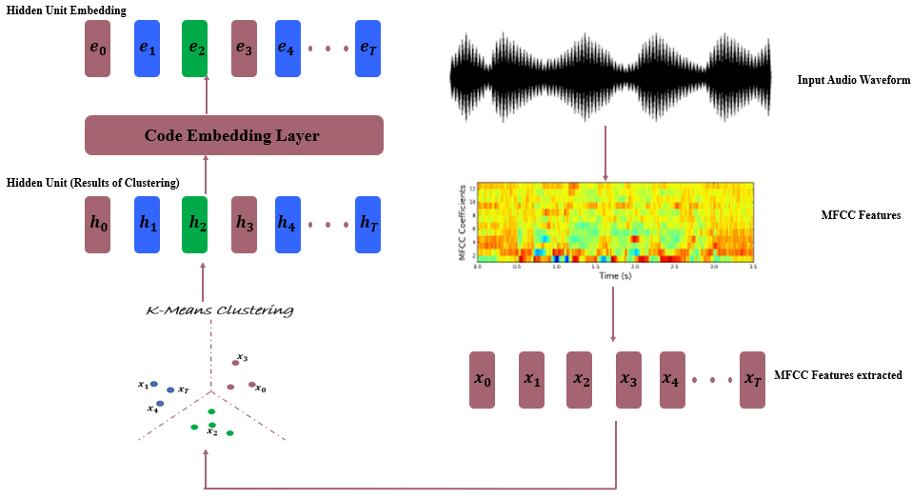
Figure 2: Iteration 1 Clustering for Hidden Unit Generation
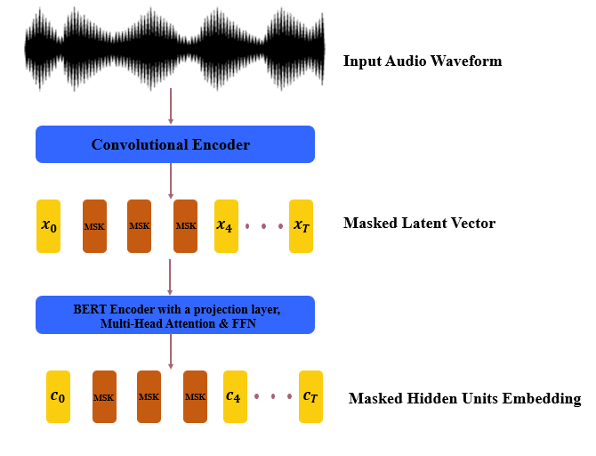
Figure 3: Hidden Unit Generation at the BERT Encoder Output for Iteration 1

4.1.2 Iteration 2 Clustering
As indicated in Figure 4, the clustering approach in iteration 2 is to utilise the output of the BERT transformer of the previous iteration 1. In fact, the 6th BERT transformer output layer of iteration 1 is utilised for clustering where the value of K is set to 500 to generate better targets [7]. This is indicated on the right hand side of Figure 4 where the vector output of the 6th layer is fed to the clustering layer. This approach to clustering is to ensure better target quality and prediction of the masked hidden units from the output of the BERT encoder.
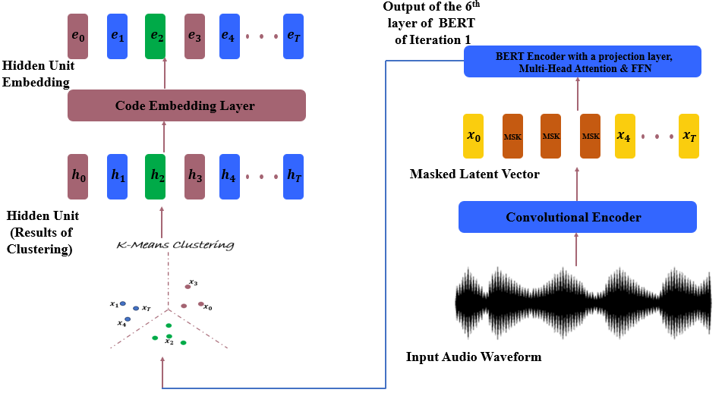
Figure 4: Iteration 2 Clustering for Hidden Unit Generation

4.1.3 Iteration 3 Clustering
In iteration 3, the intermediate layer of the BERT transformer output is used for clustering instead of the MFCC features utilised in iteration one. Unlike the 6th BERT output layer used in the second iteration, here the 9th output layer of the BERT transformer is used. This is depicted in Figure 5. The value of K set for the clustering in this step is also 500 just like the second iteration for the same reason of better targets generation [7].
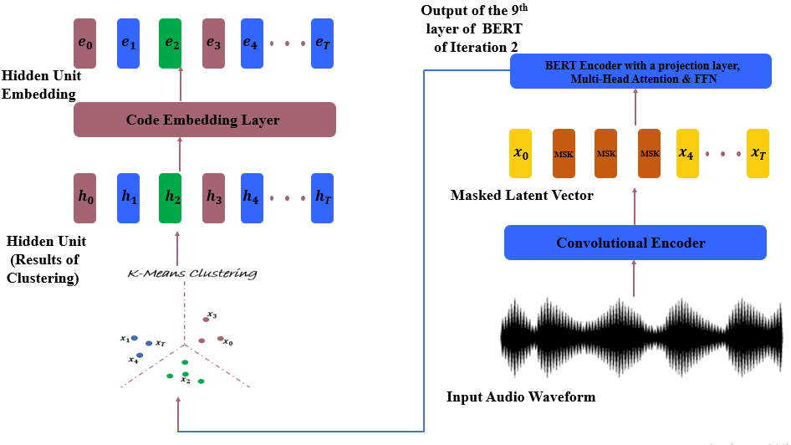
Figure 5: Iteration 3 Clustering for Hidden Unit Generation

4.2 Prediction Steps
As shown in Figure 6, the training process in the first iteration for HuBERT model involves inputting raw waveform into the convolutional encoder and MFCC feature extraction layer. The output of the convolutional encoder is fed to the BERT transformer where masked hidden units are obtained. These are the units to be predicted. In addition to this are the hidden units’ embeddings (pseudo-target) obtained from the clustering of the MFCC feature vectors. These hidden units are utilised to make predictions of the masked hidden units (masked language modelling) of the output of the BERT transformer encoder. Then the cosine similarity between the two corresponding hidden units is obtained to get the prediction logits. Thereafter, the cross-entropy loss function is obtained to penalise wrong predictions. The authors of HuBERT paper [7] also developed formulas to predict only masked target, only unmasked target, and both masked and unmasked target. 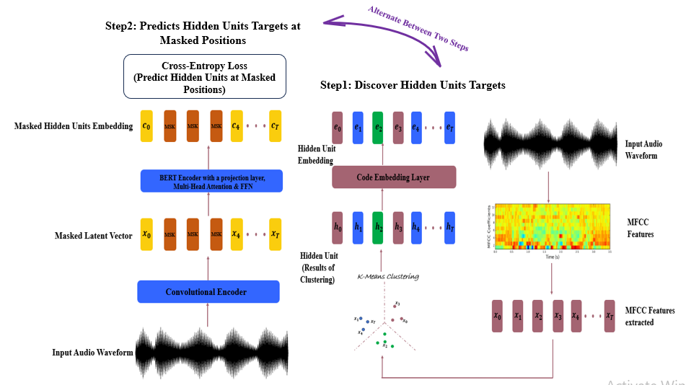
Figure 6: Iteration 1 Prediction of HuBERT Model

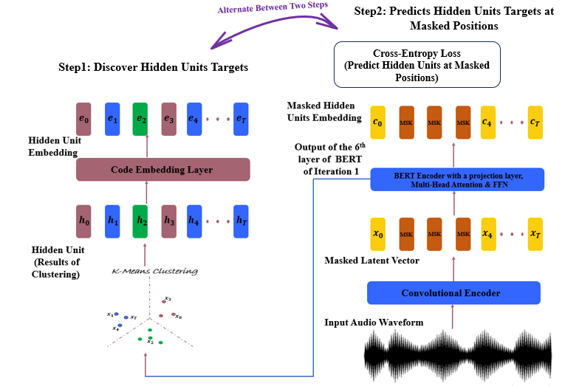
Figure 7: Iteration 2 Prediction of HuBERT Model

The second iteration training procedure shown in Figure 7 is similar to that of the first iteration except that during this time, the model is trained with 6th BERT output layer of iteration 1 for the clustering. Every other procedure remains the same. In Figure 8, the 9th BERT output layer is utilised to train the model for the clustering steps while the output hidden units obtained here have the same procedure as that of the second and first iterations training procedures.

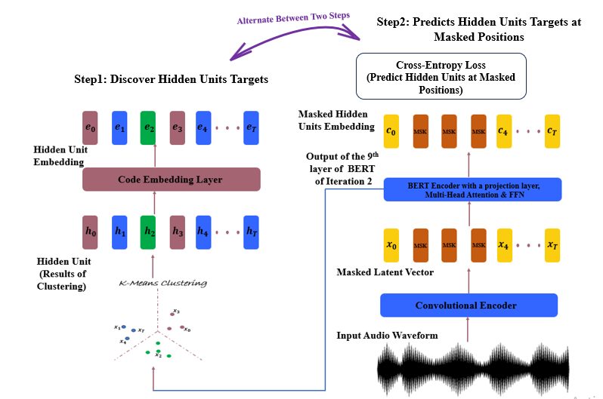
Figure 8: Iteration 3 Prediction of HuBERT Model

4.3 Fine-Tuning of HuBERT
For automatic speech recognition (ASR) finetuning, the Connectionist Temporal Classification (CTC) loss function is used where the projection layer is also replaced with random softmax layer that has been initiliased. In the paper, for speech recognition fine-tuning, the authors [7] utilised both transformer and n-gram language models trained on Librispeech dataset. The HuBERT model can be fine-tuned for speech recognition and generation tasks [7]. To fine-tune the HuBERT model, certain amounts of labelled data are utilized. According to [7], pre-training a HuBERT model with large amount of unlabeled speech data demands less amount of labelled data for model fine-tuning with state-of-the-art (SOTA) WER results. Thus, in [7], pre-trained HuBERT models are fine-tuned in 10 mins, 1 hrs., and 10 hrs., of Libri-Light labelled data; 100 hrs., and 960 hrs., of LibriSpeech labelled data, and the results obtained were compared with Wav2vec 2.0 BASE, & LARGE, and DiscreteBERT [25]. When just 10 min of labelled Libri-Light (60K) was utilized, HuBERT achieved WER of 4.6 % and 6.8 % in comparison to Wav2Vec 2.0 LARGE with 4.8 % and 8.2 % for test-clean and test-other respectively.

5. Review of Related Works
In [4], a transformer-based direct S2UT model was developed where the input source speech was transformed into mel-spectrogram, and target was discrete representation of the target speech obtained using HuBERT Base model [7]. Target speech waveform from self-supervised target discrete units predicted using vocoder, and target texts (used for written target language and obtained using CTC decoder) were obtained from the architecture. The architecture involves joint training of speech mel-spectrogram (source), texts (source and target – for written language), discrete units (target, and source – for auxiliary training), phonemes (source and target), and characters (source and target). Also, characters, or phonemes were outputted as auxiliary output during training. Discrete units were generated using stacked and reduced (removal of consecutive duplicate units) approaches. The model was trained using Facebook FAIRSEQ S2T. The Fisher Spanish-English dataset [26] for AST containing the Spanish audios, texts, and corresponding English translation was utilized. A single female voice TTS was used to synthetically generate the English target speech replica of the source Spanish speech. Results showed that direct S2UT has improved performance over direct S2ST mel-spectrogram-based model, and with closer performance to cascaded model. For instance, S2UT reduced with CTC (to output target texts) has BLEU score of 39.9 while spectrogram-based Translatotron, cascaded model (ASR+MT+TTS), and cascaded model (S2T+TTS) have BLEU scores of 33.2, 43.9, and 40.2 respectively on test set. The direct S2UT model was 1.5 x faster and 1.3 x faster than cascaded based S2T+TTS and Transformer Mel-spectrogram-based Translatotron model respectively. It was also shown to be more efficient than both in terms of memory usage and the number of floating-point operations (FLOP) [4]. [27] developed an End-to-End (E2E) TTS NMT model using Vector Quantization Variational Auto Encoder (VQ-VAE) to generate the discrete representation of target speech unlike the use of HuBERT, Wav2Vec 2.0 etc. in other research works. It should be noted that the training here is supervised training (In the experiment carried out in [7], and other unsupervised models including ASR, TTS, the VQ-VAE is utilized only on raw speech where it is used to generate discrete labels (equivalent of text tokens) utilized for trainings [26]). VQ-VAE with encoder-decoder architecture was first trained to learn mapping of waveform to discrete representation, after which the discrete symbols were converted to sub-word sequence using SentencePiece encode. The sub-word sequence (target) with text (source) was utilized for training, and the predicted discrete symbols were converted to the target speech using VQ-VAE decoder. The result of the experiment was compared to the conventional TTS mel-spectrogram-based model with parallel WaveGAN [28]. The Japanese JSUT TTS corpus [29] was utilized for model development. It is a single female speaker Japanese speech, and it consists of the speech and the corresponding text. Using ESPnet-TTS, an open-source toolkit, a TTS NMT VQ-VAE based model was developed. Results show that VQ-VAE based TTS NMT model achieved a MOS naturalness of 3.99 $±$0.06 when reconstruction with a small Down Sampling Factor (DSF) of 128 was considered in comparison to the conventional parallel WaveGAN TTS NMT-based model with MOS value of 3.48 $±$ 0.08. CERs of 14.8 and 15.1 were also obtained for VQ-VAE TTS and conventional TTS models respectively. The limitation of the experiments carried out was using smaller DSF, which made the NMT training difficult. In [30], Audio Visual S2ST and S2ST self-supervised based models were developed. The source audio+visual were fed as input into an encoder-decoder sequence-to-sequence NMT and target was the discrete representation of the target speech obtained using self-supervised HuBERT model [7]. Three different models were trained: V2ST, AV-S2ST, and S2ST model trainings, where the discrete representation of the target speech was utilized while source speech and audio for AV-S2ST was fed through a multilayer audio and video feature extractors after which it was fed to the NMT model. A unit-based Vocoder that maps discrete to audio was used to generate the target speech. A self-supervised Audio-Visual Hidden Unit BERT (AV-HuBERT) model [31] and pre-trained S2ST [32] using Wav2Vec 2.0 [5], a self-supervised model and mBART [33] were utilized to learn contextual representation due to data scarcity and to also boost performance of the AV S2ST model developed. Using LRS3 [34], parallel AV to audio dataset was curated, and the CVSS – C [35], a single speaker canonical dataset was used for S2ST training. Both datasets were for English-to-Spanish and English-to-French parallel corpora. Using FIARSEQ framework, results show that self-supervised pretraining (AV-HuBERT) and no self-supervision yielded BLEU scores of 45.2 and 0.67 respectively for English-to-Spanish for AV only model. For Audio only model, self-supervised pretraining (AV-HuBERT) and no self-supervision yielded BLEU scores of 31.6 and 0.90 respectively. While the above literature looked into S2UT, TTS, and S2ST using unit target, [36] developed an automatic text translation from one language to another language. The input to the model, was the source texts in any one language while the target is the discrete representation of speech of a different English target language obtained using mHuBERT. The output discrete target when trained on CVSS-C S2ST corpora was converted to target speech using HiFiGAN vocoder. To develop the proposed text-to-unit model, two variants of mBART (mBART25 and mBART50), which are text-to-unit pretrained models, were fine-tuned for the encoder-decoder text-to-units model developed. Results show that for high-resourced language, mBART50 performs better than the cascaded approach (utilising MT, and mBART50), where BLEU scores of 24.4, 32.1, and 29.7 were obtained for mBART25, mBART50, and cascaded models respectively.

6. Methodology

6.1 Experiment Setup

6.1.1 HuBERT vs MFCC
Unit based speech generation using unit HiFi-GAN and spectrogram-based speech generation experiments were carried out. The experimental setup was carried out on NVIDIA GeForce RTX 4060 GPU Laptop. 1000 audio samples (all female speakers of the public health-malaria) were selected from the Yoruba section of the GC-ENYOR dataset curated through crowd-sourced participants across 4 universities in Nigeria including University of Lagos, Lagos State University, Federal University of Agriculture Abeokuta, and University of Ibadan. The dataset is a pair audio of both English and Yoruba curated to aid research in speech processing applications. It has a total size of over 100,000 audio samples each of English and corresponding Yoruba languages. For both setups, 900 audios were utilized for training and 100 audios for validation.
The pretrained models of both the unit HiFi-GAN and HiFi-GAN were cloned as well as their pretrained checkpoints. The hyperparameters utilized for training are shown in Table 3.
Table 3: Hyper parameters utilized for discrete plus audio & spec plus audio trainings
S/N | Hyperparameters | HiFi-GAN | Unit HiFi-GAN
1 | Number of units | Nill | 500
2 | Batch size | 16 | 16
3 | Sampling rate | 25050Hz | 16000Hz
4 | Learning rate | Gen: 0.0001; disc: 0.0001 | 0.0001
5 | Learning rate decay | 0.995 | Nill
6 | Adam optimiser (betas) | 0.8, 0.99 | 0.8, 0.99
7 | Loss weight factor (gamma) | Nill | 0.999
8 | hop size / Unit hop size | 256 | 320
9 | Maximum epoch | 10,000 | 2,000
10 | Maximum steps | Nill | 50,000
11 | Number of mels | 80 | Nill

For MelSpectrogram plus audio finetuning, MelSpectrograms of 1000 audios were extracted after sampling the audios to 25KHz, the sampling rate for HiFi-Gan finetuning, and saved with. npy extension. The hyperparameters such as the learning rate, sampling rate, learning rate decay, as shown in Table 3 were set. For the unit HiFi-GAN, the discrete units were first extracted using pretrained HuBERT checkpoint with K = 500 and saved as .npy extension. The discrete values of all .npy files were then extracted in order to be used as input data needed for finetuning. For this, the sampling rate of all audios was set to 16KHz to tally with the sampling rate needed for finetuning set up of the unit HiFi-GAN, and as indicated in Table 3.
The MelSpectrogram plus audio pair were then finetuned starting with a pretrained checkpoint of g_00000000. In the other experiment, the discrete integers with audio pair were also finetuned starting with the HuBERT pretrained checkpoints. For HiFi-GAN, training continues till over 90K steps when it was terminated due to no improvement in the speech intelligibility. For the unit HiFi-GAN, the finetuning was run for the full 50K global steps (892 epochs) set for finetuning (approximately 16 hours).

6.1.2. HuBERT Versus Other Discrete Unit Generation Models
Further experiments carried out involving the comparison of speech generation using discrete units of HuBERT, Wav2vec, and WavLM. Using the same audio sampling frequency of 16KHz (as for HuBERT), discrete units were also generated using Wav2vec and WavLM models. Unlike HuBERT discrete unit generation using HuBERT pretrained checkpoint, both wav2vec and WavLM were first pre-trained using the same cluster size of 500 utilised for HuBERT, and their respective discrete units for the 1000 audios consisting of 900 and 100 for training, and validation respectively, were generated. The same hyperparameters setup of Table 3 (HuBERT + unit HiFi-GAN finetuning) were used for the finetuning of both wav2vec + unit HiFi-GAN and WavLM + unit HiFi-GAN setup, setting the maximum global steps to 50, 000 (maximum epochs = 892).

7. Results and Discussion

7.1 Melspec Plus Audio Experiment (HiFi-GAN)
Audios were sampled at different global steps to check for audio intelligibility. It was observed that the first set of audios which had some background noises were produced at about 11,000 steps. At about 27,000 (492 epochs) global steps, the audio became more intelligible than the ones obtained at earlier global steps, and over 28,000 global steps (505 epochs), the generator loss total spiked up to hundreds of thousands of values which forces the training to be terminated. The hyperparameters were then adjusted and training resumed and it was observed there was no improvement in the intelligibility of audio produced at higher global steps like 40K, and 90K where audios were tested. The audio produced at this stage still has faint background noises that seem to erode or fade the speech produced.

7.2 Discrete Unit Plus Audio Experiment (HuBERT Plus Unit HiFi-GAN)
Unlike the spectrogram audio-based generation, it was observed that at about 14,000 global steps (250 epochs), the speeches produced were more intelligible and clearer to hearing compared to those produced by the spectrogram based, even though the mel spec error for training and validation were higher than those of MelSpectrogram plus audio-based model. As finetuning proceeded, speech intelligibility became clearer even at higher global steps say at 32K global steps (572 epochs). The speech became clearer when compared to its spectrogram-based counterpart at this high global step. At the end of the finetuning (50,000 steps / 892 epochs), a training mel loss, generator train loss, and discriminator train loss of 0.7553, 46.3575, and 2.4235 respectively were obtained while that of the validation mel loss, generator validation loss, and discriminator validation loss were 1.0465, 58.87043, and 2.49985 respectively.

7.3 HuBERT Plus Unit HiFi-GAN Versus HiFi-GAN

7.3.1 Size and Memory Space
It was observed the .npy files of the 1000 audios had reduced size of about 1.61 MB for the HuBERT discrete units when compared to the .npy file size of 206 MB of that of MelSpectrogram. This is about 99.21 % reduction in size utilising discrete unit approach. This also implies the training runs faster than spectrogram-based speech generation model, highlighting the reduction in storage and memory requirements, using discrete approach while still retaining enough information of the original audios.

7.3.2 Global Steps Comparison for Loss
Table 4 shows that between 11000 global steps and 20000 global steps, Spectrogram plus Audio-based model had train mel loss drops to 0.026 by 20k steps (Figure 9), validation mel loss stays low (approximately 0.03–0.07) (Figure 10), showing strong generalization, and converges quickly with very low error values. However, for Discrete Units plus Audio based-model, train mel loss remains higher (approximately 0.89–0.97) across 11k–20k, while validation mel loss also was higher (approximately 1.05–1.15)-this shows that convergence is slower in terms of mel loss, but training is stable and consistent. This implies that on the same GC‑ENYOR dataset, spectrogram‑based HiFi‑GAN achieves much lower mel losses (better raw spectral fidelity). Unit HiFi‑GAN shows higher mel losses, but with good audio quality obtained — as discrete units often yield better phonetic clarity and robustness.

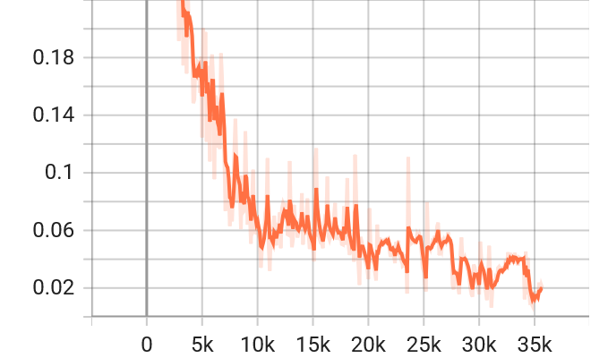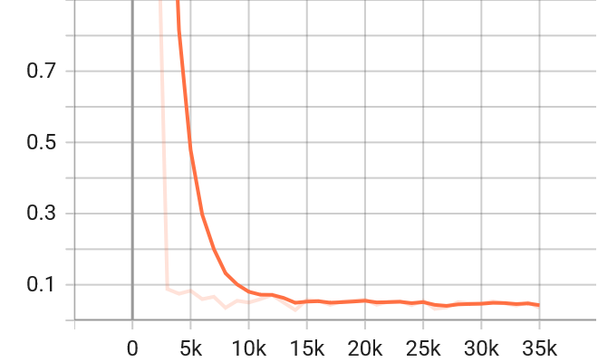
Figure 9: Train Mel Loss of Spectrogram Figure 10: Validation Mel Loss of Disctrete
Based HiFi-GAN Unit Based HiFi-GAN
Table 5 also shows similar trends were also obtained between 21K and 30K global steps. For Spectrogram plus Audio-based model, train mel loss drops to approximately 0.015 by 30k, its validation mel loss stays low and stable (approximately 0.03–0.05). This shows excellent convergence and spectral fidelity. For discrete Units plus Audio-based model, train mel loss remains higher (with approximately 0.82–0.88) across 21k–30k, but slightly lower than those of Table 4. Its validation mel loss is also higher (approximately 1.04–1.12)-thus, it shows convergence is slower in mel loss terms, but training is stable and consistent.
Table 4: Mel Loss of Unit HiFi-GAN and HiFi-GAN Between 11k to 20K Global Steps
Global Step | Spectrogram Train | Spectrogram Val | Discrete Train | Discrete Val
11k | 0.050 | 0.0597 | 0.972 | 1.155
12k | 0.073 | 0.0712 | 0.964 | 1.138
13k | 0.072 | 0.0501 | 0.951 | 1.137
14k | 0.063 | 0.0290 | 0.933 | 1.119
15k | 0.038–0.117 | 0.0577 | 0.924 | 1.073
16k | 0.064 | 0.0577 | 0.922 | 1.079
17k | 0.054–0.059 | 0.0435 | 0.911 | 1.054
18k | 0.051–0.077 | 0.0531 | 0.907 | 1.136
19k | 0.036–0.086 | 0.0558 | 0.899 | 1.105
20k | 0.026 | 0.0583 | 0.894 | 1.079

Table 5: Mel Loss of Unit HiFi-GAN and HiFi-GAN Between 21k to 30K Global Steps
Global Step | Spectrogram Train | Spectrogram Val | Discrete Train | Discrete Val
21k | 0.051–0.054 | 0.044 | 0.883 | 1.017
22k | 0.041–0.049 | 0.052 | 0.878 | 1.117
23k | 0.035–0.043 | 0.054 | 0.863 | 1.097
24k | 0.051–0.057 | 0.043 | 0.864 | 1.083
25k | 0.031–0.079 | 0.055 | 0.860 | 1.109
26k | 0.046–0.056 | 0.032 | 0.859 | 1.060
27k | 0.052–0.054 | 0.037 | 0.855 | 1.060
28k | 0.015–0.055 | 0.051 | 0.834 | 1.046
29k | 0.013–0.036 | 0.048 | 0.833 | 1.040
30k | 0.015 | 0.048 | 0.822 | 1.086

7.3.3 General Comparison
Table 6 further shows a comparison of the two models in terms of the dataset utilized, the global steps at which speech first emerge, the generator loss obtained at 27K global steps etc.
Table 6: Comparison of results
Aspect | MelSpec + Audio (GC-ENYOR) | Unit HiFi-GAN (HuBERT Discrete + Audio)
Dataset | Same 1000 audios (900 train, 100 val) | Same 1000 audios (900 train, 100 val)
Speech Emergence | ~11k steps (speech audible, but muffled) | ~14k steps (speech audible, clearer)
Clarity Progression | Plateau around 35k, faint background noise, little improvement | Still improving at 32k, clarity increasing
Training Stability | Loss spike at ~28k (catastrophic, required reset) | Stable, no catastrophic spikes
Generator Loss Trend | Dropped to around 20 at 27K steps | Gradual decline to about 56.30 at 27K steps
Phonetic Accuracy | Captures prosody, but muffled clarity | Better phonetic precision, clearer articulation
Naturalness | Richer timbre, but noisy | Cleaner phonetics, slightly robotic timbre
Noise/Artifacts | Faint background noise persisted | Less noise, but unit resolution affects smoothness

7.3.4 Evaluation Metrics Comparison for HiFi-GAN and HuBERT Unit HiFi-GAN
Tabe 7 shows further evaluation metrics such as the PESQ, STOI, and Deep Noise Suppression MOS (DNSMOS) obtained for the discrete unit-based HuBERT model generated audio samples in comparison to the ground-truth. The result shows that the PESQ score has poor performance across the 4 samples. However, for STOI, sample 3 has the highest score of 0.7600 which implies that speech is in good intelligibility zone. The DNSMOS gave the best evaluation result where the samples generated of 1, 3, and 4 scored higher than their reference audios. Sample 4 gave the best result with a score of 3.005651, and 2.671266 for the generated and reference audio samples respectively.
Table 7: Generated vs original for unit HiFi-Gan at 32,000 Global Steps
File Pair | PESQ | STOI | DNSMOS (Generated, Original)
generated_1 vs original_1 | 1.0800 | 0.6600 | 2.7079, 1.8926
generated_2 vs original_2 | 1.1290 | 0.6188 | 2.5774, 2.7290
generated_3 vs original_3 | 1.2783 | 0.7600 | 2.7810, 1.9979
generated_4 vs original_4 | 1.0687 | 0.5260 | 3.0056, 2.6712

Table 8 shows the equivalent result of Table 7 when the metrics were evaluated (generated) for the same four samples of audios listed in Table 7 using HiFi-GAN (spectrogram based) at 45000 global steps. It can be seen that even though audios generated by HiFi-GAN were faint, with background faint noise, it has the best evaluation using STOI where it has highest score of 0.71 for sample 3 depicting it has a moderate level of intelligibility. However, its PESQ, and DNSMOS metrics results were very poor. The DNSMOS further shows the generated samples could not be compared to the original samples unlike the result of unit HiFi-GAN where some generated audio samples were scored higher than original samples. The results of Tables 7 and 8 show that unit HiFi-GAN is better for speech generation than utilising HiFi-GAN (spectrogram based).
Table 8: Generated vs original for HiFi-Gan at 45,000 Global Steps
File Pair | PESQ | STOI | DNSMOS (Generated, Original)
generated_1 vs original_1 | 1.0328 | 0.6847 | 1.3705, 1.8926
generated_2 vs original_2 | 1.0469 | 0.6375 | 1.3160, 2.7290
generated_3 vs original_3 | 1.0415 | 0.7123 | 1.3970, 1.9979
generated_4 vs original_4 | 1.0349 | 0.6932 | 1.5106, 2.6712

7.3.5 Generation Versus Ground Truth
Both models gave promising results when tested for samples used during training and off training. Unit HiFi-GAN gave the best speech intelligibility when compared to HiFi-GAN as the generated audio became so clear even at lower global steps of 14K. The speech became even clearer at higher global steps. When unit HiFi-GAN was tested at 32K, 45K, and 50K steps, it gave output so close to the reference in terms of its naturalness, and these results are backed up by Tables 7 and 8. For HiFi-GAN, The generated audios were not close to the ground in terms of content but with background noise that eroded the speech.

7.3.6 Unseen Data Comparison
The unseen data during training for HiFi-GAN appears to be heard well compared to that of the unit HiFi-GAN, even though there were faint background noises. This does not mean the unseen data tested on Unit HiFi-GAN do not sound intelligible. This shows that both models generalise well to unseen data.

7.3.7 Discrete Units Comparison (HuBERT vs Wav2vec vs WavLM)
The results of the experiments when discrete units from each of wav2vec and WavLM were fed to unit HiFi-GAN are given in Tables 9 and 10. The two tables show the PESQ, STOI, and DNSMOS results computed at 45K global steps, on four audio samples utilized for testing the output of the finetuned models. Table 9 shows that for wav2vec, file pair 3 has the best results in terms of speech quality and intelligibility, while pair 1 has the best DNSMOS result in comparison to others where its generated samples was rated high to be 3.02 which is 1.13 higher than that of the original sample. These results were also supported in Table 10 for WavLM discrete unit based. However, the generated audio sample of pair 4 has the highest DNSMOS of 3.11 in comparison to 2.67 for its original audio sample.
Table 9: Speech Generated Results using Wav2vec Discrete units at 45K Global Steps
File Pair | PESQ | STOI | DNSMOS (Generated, Original)
generated_1 vs original_1 | 1.0910 | 0.6527 | 3.0222, 1.8926
generated_2 vs original_2 | 1.0509 | 0.5362 | 2.6728, 2.7290
generated_3 vs original_3 | 1.3361 | 0.7392 | 2.8299, 1.9979
generated_4 vs original_4 | 1.0557 | 0.4195 | 2.7671, 2.6712

Table 10: Speech Generated Results using WavLM Discrete units at 45K Global Steps
File Pair | PESQ | STOI | DNSMOS (Generated, Original)
generated_1 vs original_1 | 1.0975 | 0.6850 | 2.6767, 1.8926
generated_2 vs original_2 | 1.0805 | 0.5505 | 2.4892, 2.7290
generated_3 vs original_3 | 1.3210 | 0.7804 | 2.2298, 1.997
generated_4 vs original_4 | 1.0756 | 0.5215 | 3.1088, 2.6712

Figures 11, 12, and 13 compare the training losses for HuBERT, Wav2vec, and WavLM respectively. It can be seen that the three discretization approaches have almost same generation loss at the earlier steps in the training, but at about 10K steps into the finetuning, HuBERT and WavLM show similar trend with lower train generation loss of about 53, while wav2vec has a value of 60. At the latter end of the training at about 50K steps, HuBERT, wav2vec, and WavLM have a train generation loss of about 46, 50, and 45 respectively which shows that HuBERT and wav2vec prove to be more fasting in training than wav2vec. This was also confirmed by the quality of the audio generated from each of them.
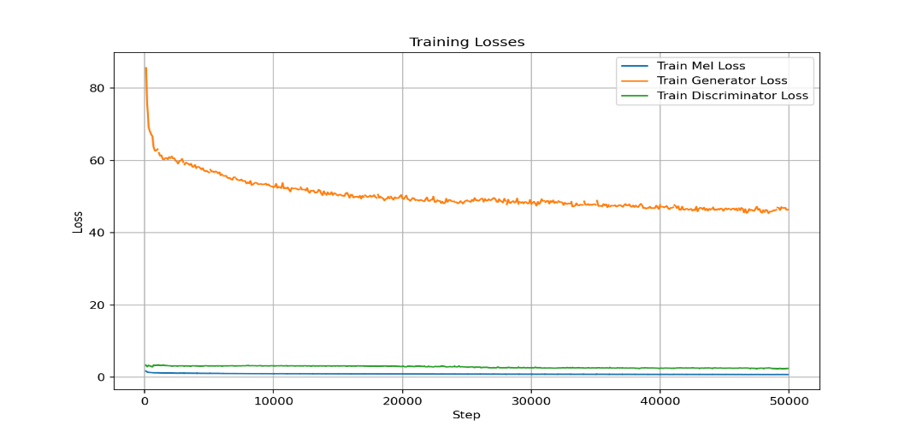
Figure 11: Training Losses for HuBERT
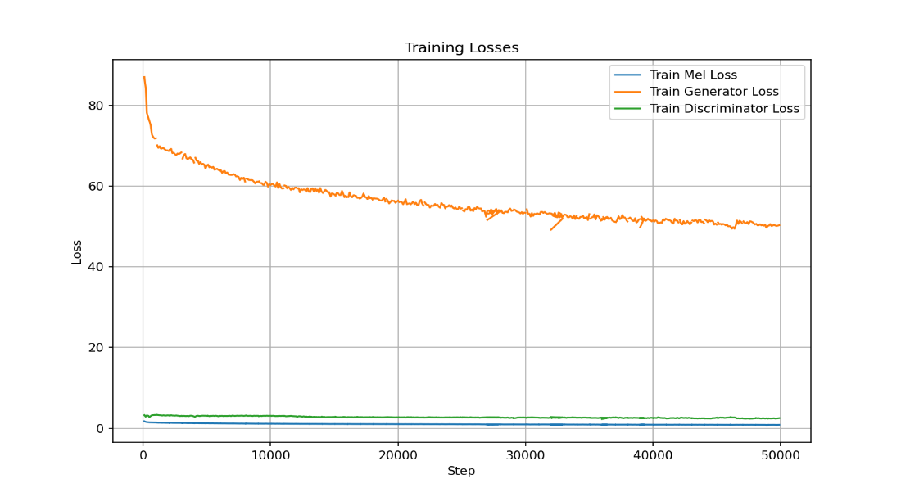
Figure 12: Training Losses for Wav2vec
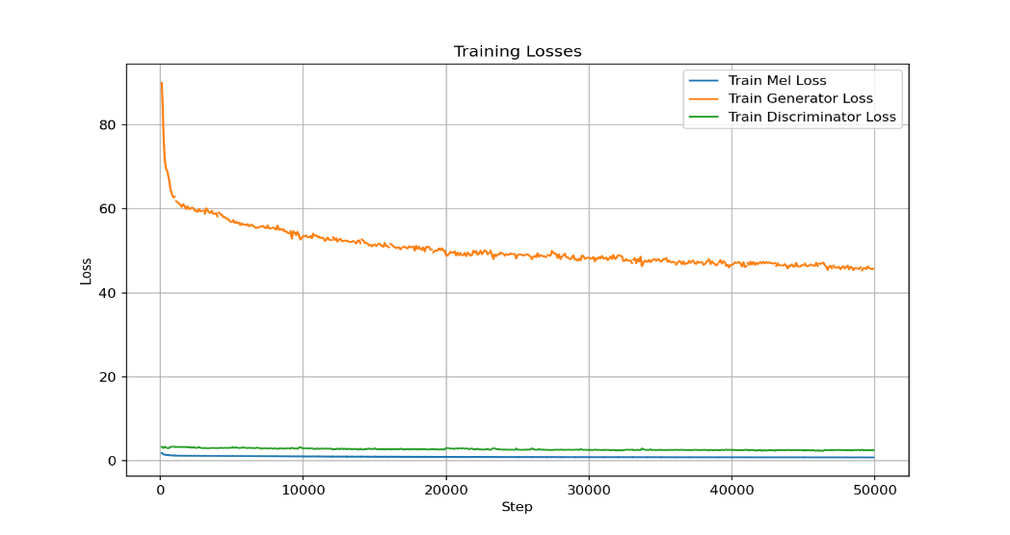
Figure 13: Training Losses for WavLM
Table 11 compares the three discretization-based models in terms of speech quality, intelligibility, and naturalness using PESQ, STOI, and DNSMOS at 32K and 45K steps. In terms of PESQ, HuBERT, Wav2Vec2, and WavLM range from 1.07–1.40, 1.04–1.33, and 1.07–1.32 respectively- these show that HuBERT and WavLM tend to edge slightly higher than Wav2Vec2, especially at later steps. In terms of STOI evaluation, HuBERT, Wav2Vec2, and WavLM range from 0.55–0.78, 0.39–0.74, and 0.52–0.78 respectively- these depict WavLM and HuBERT consistently achieve higher intelligibility scores than Wav2Vec2. Wav2Vec2 struggles most on certain files (e.g. generated_4 at 32 steps: 0.39). For DNSMOS HuBERT’s generated scores ranges from 2.46–3.15, while that of Wav2Vec2 and WavLM range from 2.03–3.06, and 2.22–3.10 respectively- these results show WavLM and HuBERT produce more stable DNSMOS values. Wav2Vec2 shows larger variance and weaker scores on some files.
Table 11: HuBERT Versus Wav2vec Versus WavLM
Model | Training Stage | PESQ (range) | STOI (range) | DNSMOS (Generated range)
HuBERT | 32 steps | 1.07 – 1.28 | 0.52 – 0.75 | 2.57 – 3.00
 | 45k steps | 1.07 – 1.40 | 0.55 – 0.78 | 2.46 – 3.15
Wav2Vec2 | 32 steps | 1.04 – 1.24 | 0.39 – 0.75 | 2.03 – 3.06
 | 45k steps | 1.05 – 1.33 | 0.41 – 0.74 | 2.67 – 3.02
WavLM | 32 steps | 1.07 – 1.20 | 0.55 – 0.76 | 2.55 – 2.69
 | 45k steps | 1.07 – 1.32 | 0.52 – 0.78 | 2.22 – 3.10

The results of these experiments show that HuBERT and WavLM are both strong candidates i.e. faster training, higher STOI, and more consistent DNSMOS. Wav2Vec2 lags behind with slower training and lower intelligibility. Between HuBERT and WavLM, the differences are subtle — HuBERT sometimes edges PESQ, while WavLM shows slightly better STOI on certain files. In practice, when speed and intelligibility are needed, HuBERT is the most balanced. If robustness and newer architecture are needed, WavLM is a solid alternative. The results show that Wav2Vec2 is not ideal for HiFi‑GAN fine‑tuning in this discrete unit setup.

8. Conclusion
The utilization of discrete hidden units solves the problem of sourcing the large volume of labeled data that is mostly difficult to get for training models particularly for speech-to-text and text-to-speech tasks. Also, hidden unit utilization for speech-to-speech ensures the complexity of the model algorithm as well as errors are reduced in comparison to the well-known Mel-spectrograms usage. Hidden unit representation usage has also been shown to give improved BLEU score performance metric in comparison to Mel-spectrogram based models. One of such hidden unit generation approach is the use of HuBERT model as highlighted in this current review study. This study gave insight into the training (pre-training) process and fine-tuning of HuBERT. Information about the unsupervised clustering process, which makes it distinct from the other similar models, was highlighted. Detailed illustrations of the model particularly the training modes involving unsupervised clustering and prediction, shows the technicality of the model, and why it gives good results when compared to other clustering approaches - this ensures better audio quality. In this paper, the results of HuBERT plus unit HiFi-GAN in comparison with spectrograms plus HiFi-GAN show HuBERT model is superior in terms of speech quality, intelligibility, and naturalness. When compared to other discrete models, it edges out both Wav2vec and WavLM. Finally, the results show that WavLM is a better alternative to HuBERT in terms of utitlising of a newer architecture and obtaining closer similar results to HuBERT.

Acknowledgement
The authors wish to acknowledge the Covenant University Center for Research, Innovation and Discovery (CUCRID), and Google for providing funds towards the publication of this study.

Reference
[1] X. Chang et al., “Exploring Speech Recognition, Translation, and Understanding with Discrete Speech Units: A Comparative Study,” Sep. 2023, [Online]. Available: http://arxiv.org/abs/2309.15800
[2] T. Nakamura, K. Choi, K. Hojo, Y. Bando, S. Fukayama, and S. Watanabe, “Discrete Speech Unit Extraction via Independent Component Analysis,” Jan. 2025, [Online]. Available: http://arxiv.org/abs/2501.06562
[3] Z. Borsos et al., “AudioLM: A Language Modeling Approach to Audio Generation,” IEEE/ACM Trans Audio Speech Lang Process, vol. 31, pp. 2523–2533, 2023, doi: 10.1109/TASLP.2023.3288409.
[4] A. Lee et al., “Direct speech-to-speech translation with discrete units,” Jul. 2021, [Online]. Available: http://arxiv.org/abs/2107.05604
[5] A. Baevski, H. Zhou, A. Mohamed, and M. Auli, “wav2vec 2.0: A Framework for Self-Supervised Learning of Speech Representations.” [Online]. Available: https://github.com/pytorch/fairseq
[6] P. K. Rubenstein et al., “Audiopalm: A large language model that can speak and listen,” arXiv preprint arXiv:2306.12925, 2023.
[7] W.-N. Hsu, B. Bolte, Y.-H. H. Tsai, K. Lakhotia, R. Salakhutdinov, and A. Mohamed, “HuBERT: Self-Supervised Speech Representation Learning by Masked Prediction of Hidden Units,” Jun. 2021, [Online]. Available: http://arxiv.org/abs/2106.07447
[8] A. Tjandra, S. Sakti, and S. Nakamura, “Speech-to-speech translation between untranscribed unknown languages,” in 2019 IEEE Automatic Speech Recognition and Understanding Workshop (ASRU), 2019, pp. 593–600.
[9] X. Li, Y. Jia, and C.-C. Chiu, “Textless Direct Speech-to-Speech Translation with Discrete Speech Representation,” Oct. 2022, [Online]. Available: http://arxiv.org/abs/2211.00115
[10] S. Chen et al., “WavLM: Large-Scale Self-Supervised Pre-Training for Full Stack Speech Processing,” IEEE Journal on Selected Topics in Signal Processing, vol. 16, no. 6, pp. 1505–1518, Oct. 2022, doi: 10.1109/JSTSP.2022.3188113.
[11] J. Devlin, M.-W. Chang, K. Lee, and K. Toutanova, “BERT: Pre-training of Deep Bidirectional Transformers for Language Understanding,” Oct. 2018, [Online]. Available: http://arxiv.org/abs/1810.04805
[12] P. K. Rubenstein et al., “AudioPaLM: A Large Language Model That Can Speak and Listen,” Jun. 2023, [Online]. Available: http://arxiv.org/abs/2306.12925
[13] L. Barrault et al., “SeamlessM4T-Massively Multilingual & Multimodal Machine Translation,” arXiv preprint arXiv:2308.11596, 2023.
[14] A. Lee et al., “Textless Speech-to-Speech Translation on Real Data,” Dec. 2021, [Online]. Available: http://arxiv.org/abs/2112.08352
[15] L. T. Nguyen and S. Sakti, “ZeST: A Zero-resourced Speech-to-Speech Translation Approach for Unknown, Unpaired, and Untranscribed Languages,” IEEE Access, 2025.
[16] P.-J. Chen et al., “Speech-to-Speech Translation For A Real-world Unwritten Language,” Nov. 2022, [Online]. Available: http://arxiv.org/abs/2211.06474
[17] H. Inaguma et al., “UnitY: Two-pass Direct Speech-to-speech Translation with Discrete Units,” Dec. 2022, [Online]. Available: http://arxiv.org/abs/2212.08055
[18] J. Shi et al., “Enhancing Speech-to-Speech Translation with Multiple TTS Targets,” Apr. 2023, [Online]. Available: http://arxiv.org/abs/2304.04618
[19] A. Diwan, A. Srinivasan, D. Harwath, and E. Choi, “Textless Low-Resource Speech-to-Speech Translation with Unit Language Models,” May 2023, [Online]. Available: http://arxiv.org/abs/2305.15405
[20] J. Duret, B. O’Brien, Y. Estève, and T. Parcollet, “Enhancing expressivity transfer in textless speech-to-speech translation,” Oct. 2023, [Online]. Available: http://arxiv.org/abs/2310.07279
[21] Z. Gong, X. Xu, and Y. Zhao, “Tibetan–Chinese speech-to-speech translation based on discrete units,” Sci Rep, vol. 15, no. 1, p. 2592, 2025.
[22] Y. Jia et al., “Direct speech-to-speech translation with a sequence-to-sequence model,” in Proceedings of the Annual Conference of the International Speech Communication Association, INTERSPEECH, International Speech Communication Association, 2019, pp. 1123–1127. doi: 10.21437/Interspeech.2019-1951.
[23] A. Polyak et al., “Speech Resynthesis from Discrete Disentangled Self-Supervised Representations,” Apr. 2021, [Online]. Available: http://arxiv.org/abs/2104.00355
[24] X. Chang et al., “The Interspeech 2024 Challenge on Speech Processing Using Discrete Units,” Jun. 2024, [Online]. Available: http://arxiv.org/abs/2406.07725
[25] A. Baevski, M. Auli, and A. Mohamed, “Effectiveness of self-supervised pre-training for speech recognition,” Nov. 2019, [Online]. Available: http://arxiv.org/abs/1911.03912
[26] M. Post, et al., 2014. “Fisher and CALLHOME Spanish English speech translation”, LDC2014T23.
Web Download. Philadelphia: Linguistic Data Consortium.
[27] Tomoki Hayashi1, Shinji Watanabe3DiscreTalk: Text-to-Speech as a Machine Translation Problem
1Human Dataware Lab. Co. Ltd., Japan 2Nagoya University, Japan 3Johns Hopkins University, USA
hayashi.tomoki@g.sp.m.is.nagoya-u.ac.jp
[28] R. Yamamoto, E. Song, and J.-M. Kim, “Parallel Wave GAN: A fast waveform generation model
based on gen erative adversarial networks with multi-resolution spectrogram,” in ICASSP, 2020,
pp. 6199–6203.
[29] R. Sonobe, S. Takamichi, and H. Saruwatari, “JSUT corpus: Free large-scale Japanese speech corpus
for end-to-end speech synthesis,” ArXiv preprint arXiv:1711.00354, 2017.
[30] R. Huang et al., “AV-TranSpeech: Audio-Visual Robust Speech-to-Speech Translation,” Zhejiang
University1, ByteDance2 {rongjiehuang,liuhuadai,zhaozhou}@zju.edu.cn
{ren.yi,liu.jinglin,yinxiang.stephen}@bytedance.com
[31] B. Shi, Abdelrahman Mohamed, and Wei-Ning Hsu. “Learning lip-based audio-visual speaker
embeddings with av-hubert,” arXiv preprint arXiv:2205.07180, 2022.
[32] S. Popuri, et. al., “Enhanced direct speech-to-speech translation using self-supervised pre-training
and data aug mentation,” arXiv preprint arXiv:2204.02967, 2022.
[33] Y. Liu, et al., “Multilingual denoising pre training for neural machine translation,” Transactions of
the Association for Computational Linguistics, 8:726–742, 2020.
[34] T. Afouras, J. S. Chung, and A. Zisserman. “Lrs3-ted: A large-scale dataset for visual speech
recognition,” arXiv preprint arXiv:1809.00496, 2018.
[35] Y. Jia, M. T. Ramanovich, Q. Wang, and H. Zen. “CVSS corpus and massively multi-lingual speech-
to-speech translation,” arXiv preprint arXiv:2201.03713, 2022.
[36] Victoria Mingote, et al., Direct Text to Speech Translation System using Acoustic Units

